# Lab: Unit Testing

This document defines the lab for ["Java OOP" course @ Software University](https://softuni.bg/modules/59/java-advanced).

# Part I: Unit Testing Basics

## Create Maven Project

Maven is build automation tool that takes care of dependencies for your project. Before you can make one, make sure that you enable the plugin in IntelliJ [File 🡪 Settings 🡪 Plugins 🡪 Maven Integration]

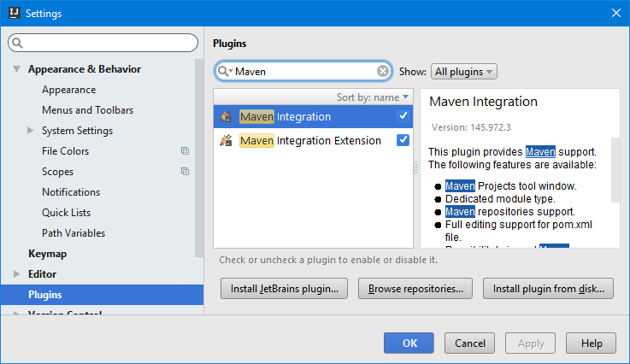

Now, you can create a Maven project

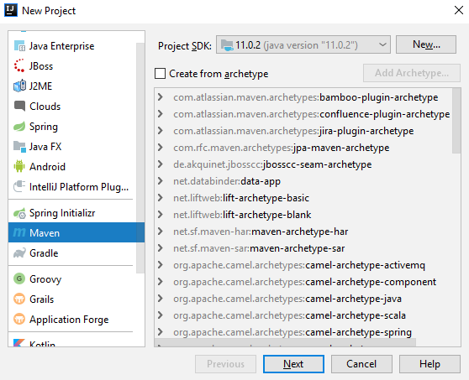

Group Id should be separated by dots, Artifact Id should be separated by hyphens

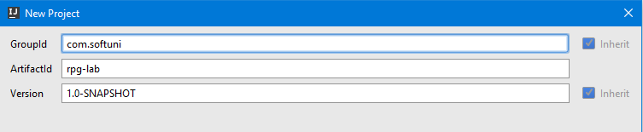

If everything is ok, you should see the following project structure

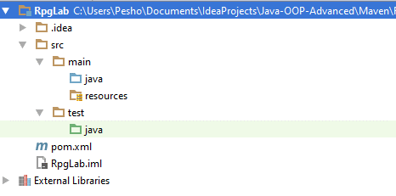

Copy the files provided and place them in a package inside src/main/java folder

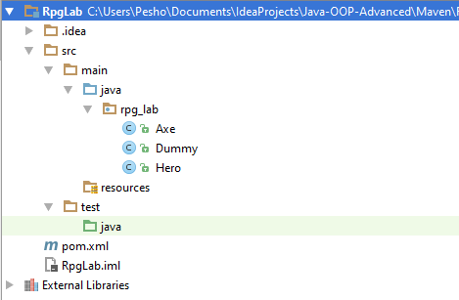

## Test Axe

In test/java folder, create a package called rpg_tests

Create a class AxeTests

Create the following tests:

* Test if weapon loses durability after each attack
* Test attacking with a broken weapon

### Solution

Create the new package rpg_tests and inside create the class AxeTests

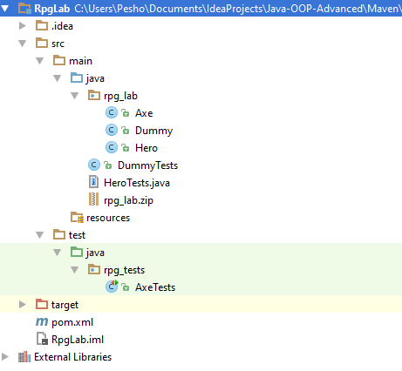

Inside the class create your first test

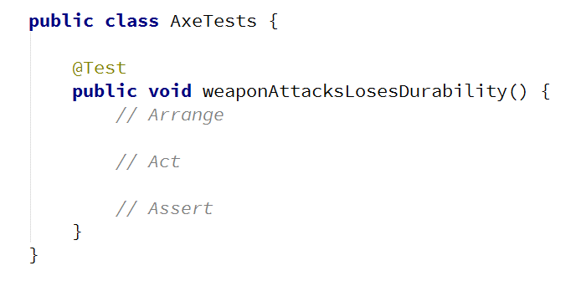

Arrange preconditions

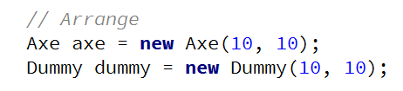

Execute tested behaviour



Assert postconditions

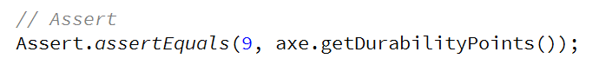

Create your second test method

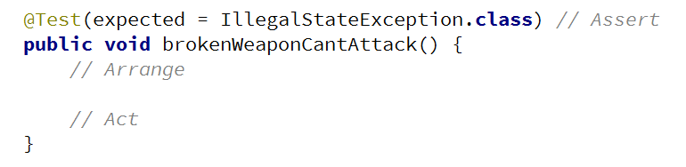

Arrange preconditions and test behaviour

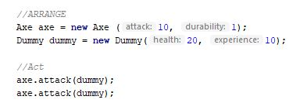

## Test Dummy

Create a class DummyTests

Create the following tests:

* Dummy loses health if attacked
* Dead Dummy throws exception if attacked
* Dead Dummy can give XP
* Alive Dummy can't give XP

### Hints

Follow the logic of the previous problem

## Refactor Tests

Refactor the tests for Axe and Dummy classes

Make sure that:

* **Names** of test methods are **descriptive**
* You use **appropriate** **assertions** (assert equals vs assert true)
* You use **assertion** **messages**
* There are **no magic numbers**
* There is **no code duplication** (Don’t Repeat Yourself)

### Hints

Extract constants and private fields for Axe class

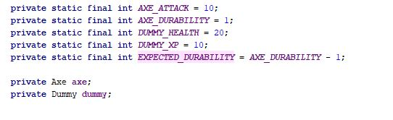

Create a method that executes **before each test**

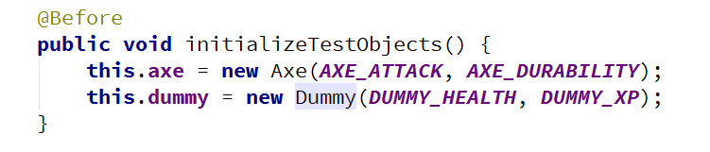

Make use of constants and private fields, as well as add assertion messages

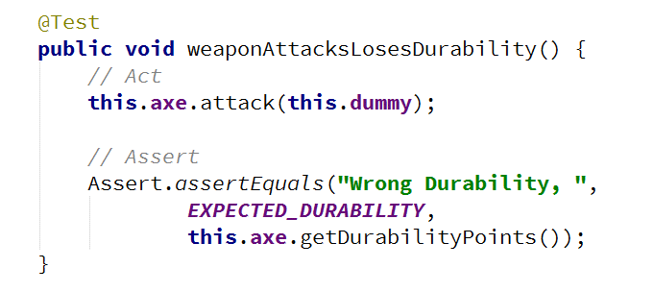

Follow the same logic for other test methods and TestDummy class

# Part II: Dependencies

## Fake Axe and Dummy

Test if hero gains XP when target dies

To do this, you need to:

* Make **Hero** class **testable** (use **Dependency Injection**)
* Introduce **Interfaces** for Axe and Dummy
  + Interface Weapon
  + Interface Target

Create fake Weapon and fake Dummy for the test

### Hints

Create **Weapon** interface

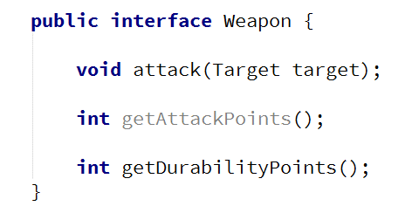

Create **Target** interface

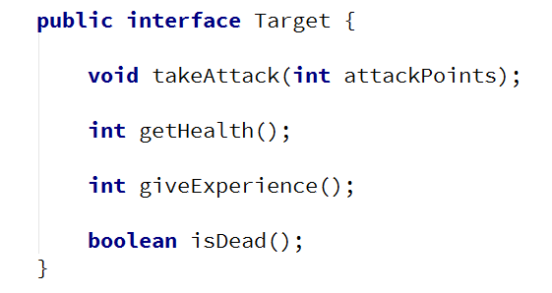

Implement interfaces



Modify implementation methods to **make use of interfaces**

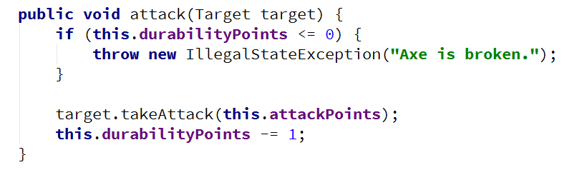

Modify both **Axe** and **Dummy** classes

Use **Dependency Injection** for Hero class

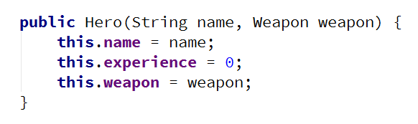

Create HeroTests class and test gaining XP functionality by faking Weapon and Target classes

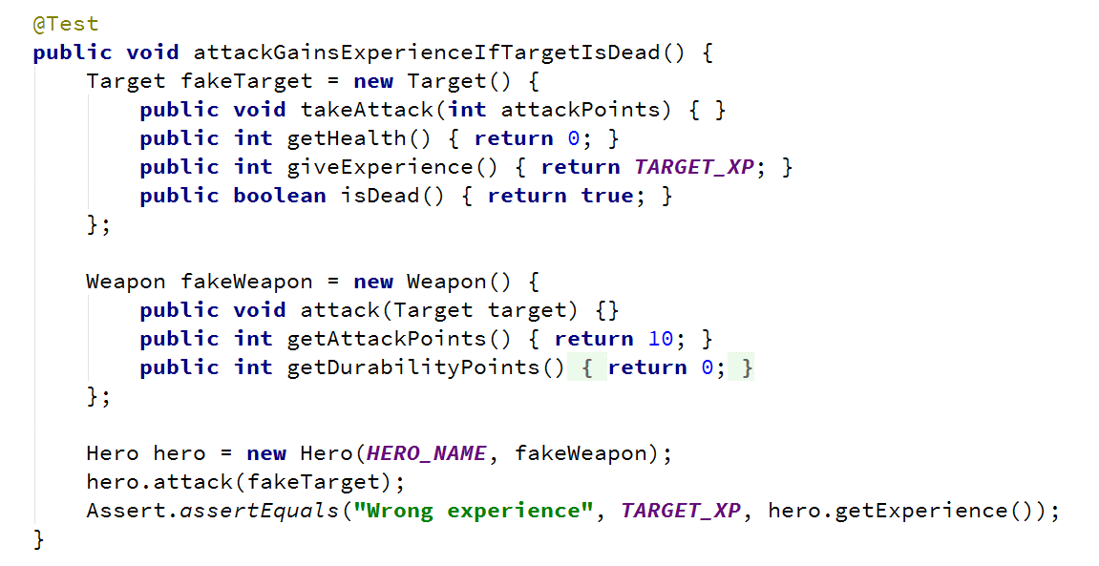

## Mocking

Include Mockito in the project dependencies, then:

1. Mock fakes from previous problem
2. Implement **Hero Inventory**, holding unequipped weapons
   1. method - Iterable<Weapon> getInventory()
3. Implement Target giving random weapon upon death
   1. field - private List<Weapon> possibleLoot
4. Test Hero killing a target getting loot in his inventory

### Hints

Locate pom.xml

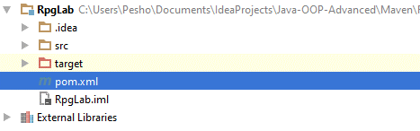

Add Mockito dependency

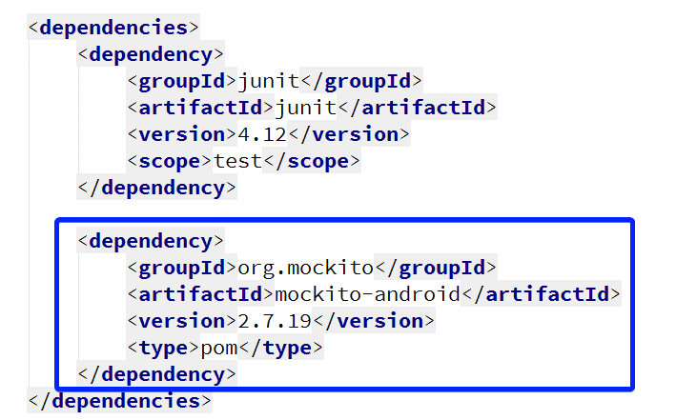

Go to HeroTests and refactor the code, making use of Mockito

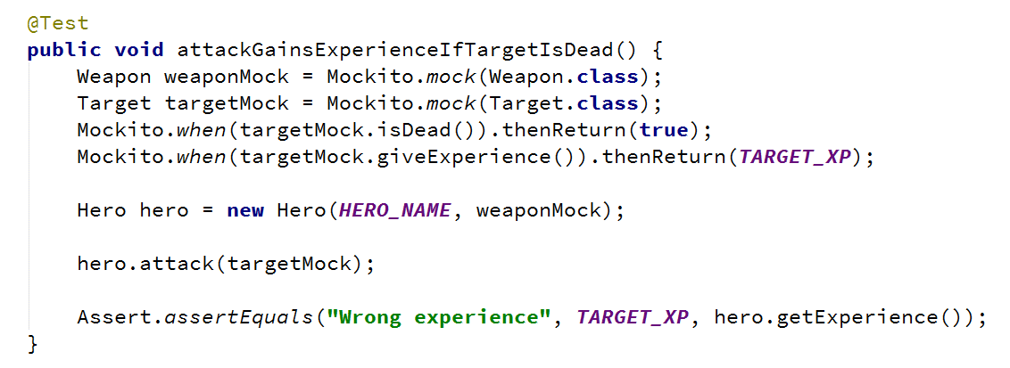

*Implement hero inventory and **Target** dropping loot functionalities

*Test **Hero** getting loot upon killing a **Target**